The 16th Tri-University International Joint Seminar and Symposium 2009
Proceedings of the 16th Tri-University International Joint
Seminar and Symposium 2009
Mie University, Japan, October 19–22, 2009
TRIU09PN-01 (paper number)

Author’s name¹, author’s name², and author’s name³

^{1,2}Academic Affiliation
e-mail:

³Academic Affiliation
e-mail:

Abstract The following instructions will provide you with guidelines for preparing papers for the Tri-U International Joint Seminar and Symposium 2009. This document is written according to the instructions you should follow. Use this document as a template if you are using Microsoft Word 2000 or newer versions. This electronic file (“Paper_Template.doc”) can be downloaded from the Tri-U 2009 website. The manuscript should be converted to an Adobe PDF file by the author. The author should send the PDF file by e-mail directly to Y. Kamada by Aug. 25, 2009. E-mail: tri-u16@ab.mie-u.ac.jp.

Key words: Paper length, paper style, headings, equations, figures and tables

1. Paper Length

The length of a student paper should be no more than 4 pages including its abstract (up to 200 words). The keynote lecturers’ papers should not exceed 8 pages including their abstracts.

The abstract should come at the beginning of your paper. It should indicate subjects dealt with in the paper and state the objectives of the investigation. Newly observed facts and conclusions in the paper must be stated in a summary form; readers should not have to read the paper to understand the abstract.

The key words should be listed at the end of the abstract. The number of key words is no more than 5.

2. Paper Style

2.1 Paper size

The size of paper is A4 (210mm x 297mm) and leaving blank space of 25 mm from the top, 20mm each from the other three sides of the paper. Type or print your paper text in two columns with 8mm space between them.

2.2 Language and font

The language of the paper is English. Do not use special fonts such as Thai, Chinese, Japanese, and so forth. Use 9 pt Times New Roman and type the text in capital and lowercase letters. Symbols and Arial font can be used as needed. The title of the paper should be typed in 14 pt Times New Roman bold font. The author’s name should be typed in 12 pt Times New Roman bold font. Keep a 1-line space between each chapter and section. Indent each paragraph two spaces.

3 Headings
- No.1 head (chapter): Use lowercase characters in bold type and capitalize the first letter. Start from the left margin with serial numbers 1, 2, 3.
- No.2 head (section): Use lowercase characters and capitalize the first letter. Start from the left margin with serial numbers 1.1, 1.2, and 1.3.
- No.3 head (sub-section): List items, using (a), (b), and (c), with no line space between them.

4. Equations

Equations should be marked with serial numbers, and enclose the equations’ numbers in round parentheses and place them flush-right in the column (see examples). When referring to an equation in the text, write “Eq. (1)” except at the beginning of a sentence, where “Equation (1)” should be used. Keep a 1-line space between the text and the equation.

$\frac{V^{2}}{2g}+\frac{P}{ρg}+z=H(=\text{const})$ (1)

$\text{Re}=\frac{\text{Vd}}{ν}$ (2)

5. Figures, Tables and Photos
If photos are needed, please use clear ones. Color prints are acceptable. The figures, tables and photos should be placed on the same page of the text. If space is limited, however, they can be arranged on the following page.
When referring to figures, photos and tables in the text, use “Fig.” and “Table.” All drawings and photos are referred to as “Fig.” Concerning the table title, the first alphabet of the first word should be written in a capital. The title of the table should be shown in the upper part of the table. The title of the figure and photo should be shown in the lower part of the figure and photo. Allow a 1-line space between the table and the title of the table (or between the figure and its caption).

Table 1. Comparison of area and population in Japan, China and Thailand.

Countries | Area (10³ km²) | Population (10⁶)
Japan | 378 | 126
Thailand | 514 | 60
China | 9,600 | 1,199

Fig. 1 Comparison of area in Japan, China and Thailand

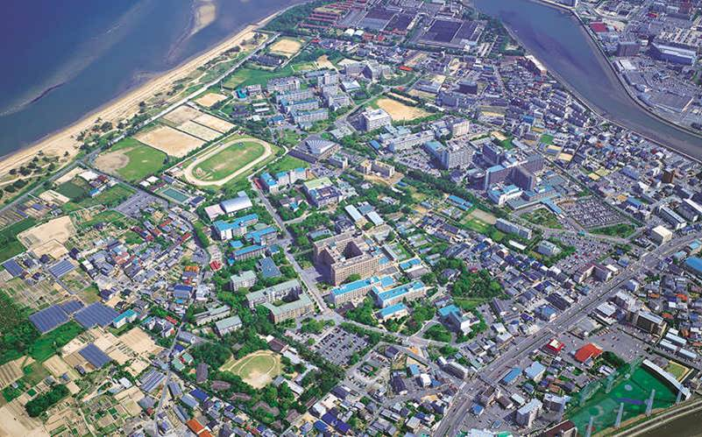

Fig. 2 Photo of Mie University’s main campus

6. Final Manuscript
The final manuscript should be converted to an Adobe PDF by the author and sent by e-mail to Y. Kamada, Mie Univ. no later than Aug. 25, 2009. (E-mail: tri-u16@ab.mie-u.ac.jp.) Please give your PDF file the paper number as its file name like “TRIU09PN-01.pdf”. Do not make a PDF file by scanning the Word file as an image. If you do not have a PDF creating software installed in your PC, please send your Word file with the file name of “TRIU09PN-01word.doc”.
Together with the PDF file of the final manuscript, the author must submit a Word file which has his/her photo and brief bio information. The template for it is downloadable from the Tri-U 2009 website.

References

The references are arranged in the order of quotation and marked with [1], [2], [3], and also marked in the text correspondingly. When referring to a reference in the text, write the number as “research^{[1]}”. The style of reference is as follows:
- B. Steen, S. O. Ryding, The EPS Enviro-Accouting Method; An Application of Environmental Accounting Principles for Evaluation and Valuation of Environmental Impact in Product Design, Swedish Environmental Research Institute (IVL) Report, 1992.
- N. Maruyama, Y. Sadamichi, A. Widiyanto and S. Kato, Environmental Impact Assessment from Operating Co-generation Systems and Power Plants, Proc. of 3rd International Energy Conversion Engineering Conference, AIAA, San Francisco, 2005, Paper No: AIAA 2005-5569, Book of Synopses and CD-ROM.
- N. Maruyama, S. Kato, Y. Kojima, A. Widiyanto and H. Takai, LCA Estimation Scheme of Co-generation System Reconcile Environmentally and Economically Eco-operations with a NETS Concept, Proc. of International Conference on Efficiency, Costs, Optimization, Simulation and Environmental Aspects of Energy Systems, Vol. 2, Eurotherm, Netherland, 2000, pp. 1093-1104.
- DN Heathfield, L. Myllerup, Wind Atlas Analysis and Application Program: WAsP 8 Help Facility. Risø National Laboratory: Roskilde, Denmark, 2005. [Online]. Available: http://www.risoe.dk/vea/projects/nimo/WAsPHelp/Wasp8.htm. (Accessed June 6, 2007)

